**Assignment 11.4**

Write a pig script to find the count of each Hashtag in the dataset. You can download the twitter data from the below link

**Pig commands:**

**LOGIC:** GOT EVERY LINE AS AN INPUT AND THEN USED TOKENIZE AND FLATTEN AND FILTER BY HASHTAGS AND MADE A COUNT

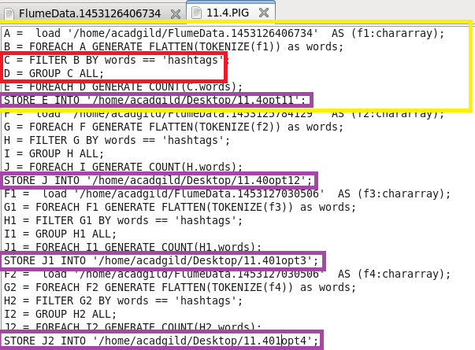

**RUNNING PIG:**

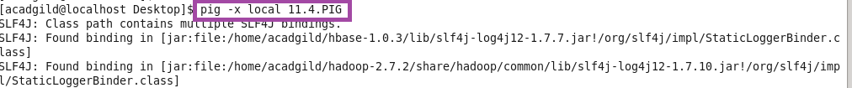

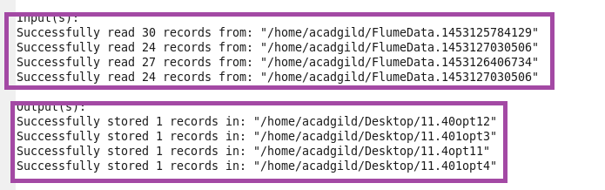

**OUTPUT:**

